Elevator System Overview
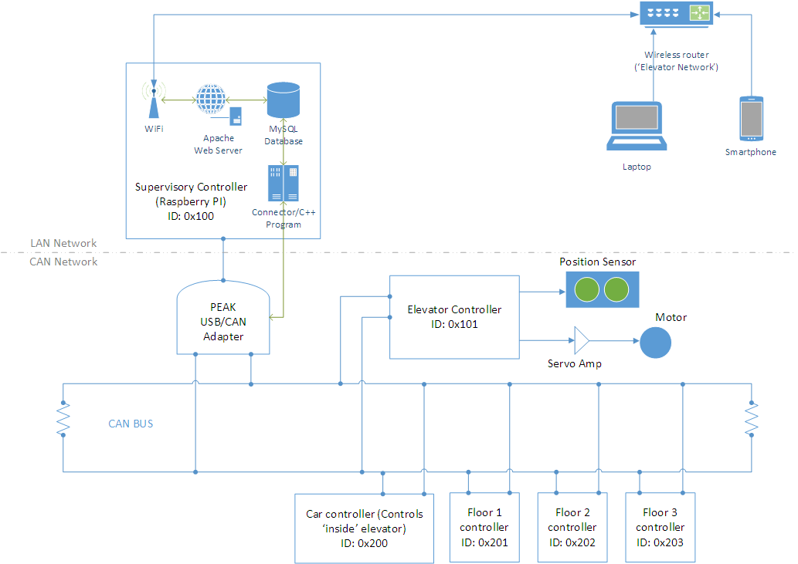
Supervisory Controller (CAN ID: 0x100)
- Raspberry PI based
- Bridges LAN and CAN network via PEAK USB/CAN adapter
- Receives its commands (floor requests) from Floor 1, 2 & 3 controllers, Car controller and Web server
- Sends commands to Elevator controller
- Implements a state machine

Elevator Controller (CAN ID 0x101)
- Accepts commands only from the Supervisory Controller (ID of message must be 0x100)
- Controls Elevator Car position via servo amp
- Reports Elevator car floor state (position) on CAN network based on inputs from the position sensor

Car Controller (CAN ID 0x200)
- Sends floor call request (and possibly door state) on CAN network to the Supervisory Controller
- Receives floor state on CAN network

Floor Controllers (CAN ID 0x201, 0x202 and 0x203)
- Send floor call requests over CAN network to the Supervisory Controller
- Receives floor state on CAN network

Common CAN Protocol Message Layout
CAN ID (Hex) | Transmitter | Recipient(s) | DLC | Byte 0
 |  |  |  | 7 | 6 | 5 | 4 | 3 | 2 | 1 | 0
0x100 | SC | EC | 1 |  |  |  |  |  | SC_Enable | SC_FloorReq
0x101 | EC | ALL | 1 |  |  |  |  |  | EC_Status | EC_Pos
0x200 | CC | SC | 1 |  |  |  |  |  |  | CC_FloorReq
0x201 | F1 | SC | 1 |  |  |  |  |  |  |  | F1_FloorReq
0x202 | F2 | SC | 1 |  |  |  |  |  |  |  | F2_FloorReq
0x203 | F3 | SC | 1 |  |  |  |  |  |  |  | F3_FloorReq
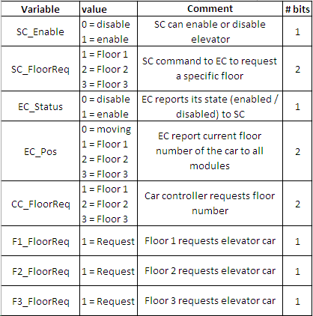
Legend
SC | Supervisory Controller
EC | Elevator Controller
CC | Car Controller
F1 | Floor 1 Controller
F2 | Floor 2 Controller
F3 | Floor 3 Controller

Note: Values in blue are transmitted over CAN network

